DSC 291 - HW 3 Report

Group: Diana Freeman, Kevin Lin, Sruthi Papanasa, Mitra Rezvany, Dante Testini

1. Summary
The goal of this analysis was to build a predictive model for New York City taxi fares using only non-fare-related trip features, such as distance, duration, and time. To do this, we used a Generalized Additive Model (GAM), which allows for flexible, non-linear relationships between predictors and the outcome.

2. Data Preparation and Feature Engineering
The data preparation process involved loading NYC TLC trip data from 2023 and normalizing column names across varied schemas, such as Yellow, Green, FHV (for hire vehicle), and HVFHV (high volume for hire vehicle) taxi types. FHV data was excluded because it lacked relevant trip fare information (trip cost). For computational efficiency, we randomly sampled 100,000 observations from the full dataset. As taxi data was split across years and months, for every 12 month files per taxi type (yellow, green, hvfhv), ~3,000 trips were sampled from each file. Feature engineering was performed by parsing datetimes to derive trip duration in minutes, the hour of the day, and the day of the week. The dataset was then cleaned by removing rows with missing or invalid values for fare, distance, or duration, and extreme outliers were trimmed using the 99th percentile for key continuous features. While the project asks to use passenger count, HVFHV taxi data does not provide this, so overall this predictor was dropped in order to keep schema and model prediction consistent. Arguably speaking, passenger count should and does not impact fare pricing. Lastly, the data was randomly split into training and validation sets based on the chosen 80/20 ratio to allow for unbiased model evaluation.

3. Fitting the GAM
The model was constructed using LinearGAM from the pygam library. The architecture combined spline terms for continuous variables, specifically trip_distance, trip_duration_min, and pickup_hour, and used factor terms for categorical features like pickup_dow. This combination allowed the model to account for both linear and non-linear effects across different feature types. We specifically define pickup_hour as a cyclic spline, as time between midnight to next day could be related.

4. Model Evaluation
The performance of the model was assessed on an unseen validation set to determine its predictive accuracy. The final pipeline performed well, achieving a validation R² of 0.864, a Mean Absolute Error (MAE) of 2.62, and a Root Mean Squared Error (RMSE) of 5.27. The results suggest that trip distance and duration are the primary drivers of cost, but time-based variables also introduce significant non-linearities that the GAM effectively captures. The scatter plot of actual versus predicted fares shows that most points are clustered tightly around the y = x line, which confirms that the model explains approximately 86.4% of the variance in taxi fares.
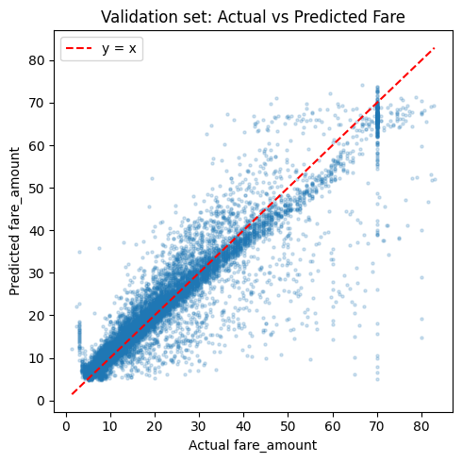

5. Interpretation of Smooth Effects
Interpretations of the model were derived from partial dependence plots, which were augmented with 95% confidence intervals to illustrate the statistical certainty of how individual features impact the predicted fare. These smooth effects revealed that trip distance and duration have strong, largely linear relationships with the fare amount, confirming their status as primary cost drivers. Furthermore, smoothing splines for the taxi year, day of the week and interaction term between distance and time, allowing the GAM to account for economic trends, weekly demand cycles and daily trip tendencies. The GAM's ability to model these non-linearities provided a more nuanced understanding of the data than traditional linear regression models.

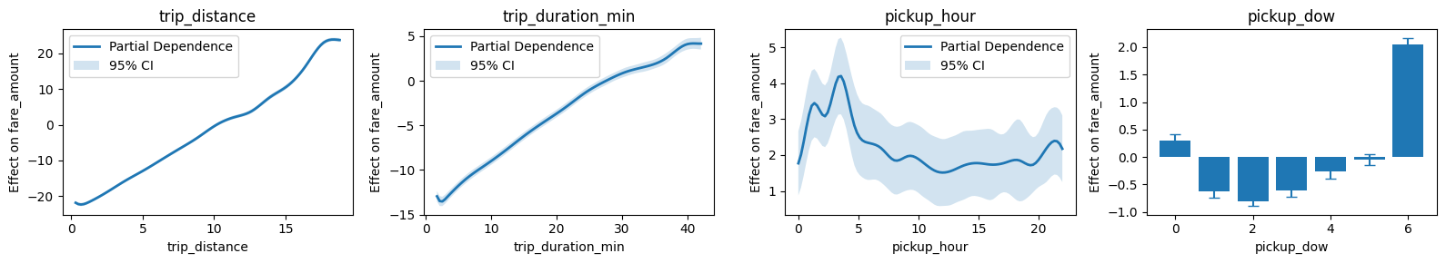

6. Limitations
There are several limitations to this model, primarily stemming from its reliance on a limited subset of trip information (see notebook on data loading). The model does not account for external factors that significantly impact fares, such as traffic conditions, specific routing, weather, or special events. It also relies on the assumption that historical relationships captured in a single-year sample will generalize across different time periods. Finally, the current analysis is restricted to one taxi type at a time; because different taxi types may encounter different fare rates and cover different geographical areas, a more robust future model would include taxi type as a predictor. Testing on isolated taxi type datasets such as 2009 yellow taxis returned more robust model R²’s up to 0.96, which was expected.

Extra Credit:
Beyond the confidence intervals in our partial dependence graph, we developed a more advanced GAM model using a mix of predictors and using log(fare) to stabilize variance and reduce outlier influence. We included an interaction term between trip_distance and trip_duration_min, as a long trip time but short distance could indicate high traffic, and vice versa. This adds a tensor / surface to capture unique interactions between trip length and time that additive smooths can’t. Additionally, we also added a pickup_year, pickup_month, and taxi_type predictors (factor, cyclic smooth, factor, respectively). This allows the model to analyze relationships between taxi types (as different taxi types travel different parts of NYC, thus having drastically different fare rates), as well as identify potential time related patterns (general inflation of fare rate over the years, peak travel seasons, etc.) Our resulting model performed significantly better, with a validation R² of 0.883, but most notably, a validation MAE of 0.12 and RMSE of 0.22.
